Project Development Phase Model Performance Test

Date | 30 September 2026
Team ID | SWTID-2026-7613
Project Name | Auto Ticket Classification using Flow Designer
Maximum Marks | 10 Marks

Model Performance Testing:
Project team shall fill the following information in model performance testing template.

S.No. | Parameter | Values | Screenshot
1. | Metrics | Regression Model: Not applicable (rule-based solution, no ML model).  Classification Model: Rule-based keyword classification using Flow Designer (If / Else If on Short Description). Confusion Matrix, Accuracy Score and Classification Report: Not applicable. Verified with 2 test scenarios (Wi-Fi, Projector) - both classified as expected. | 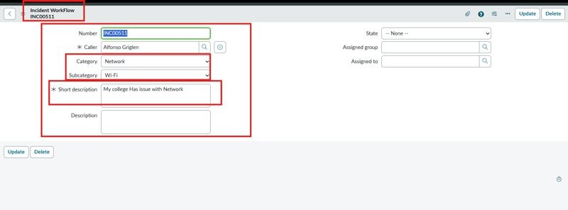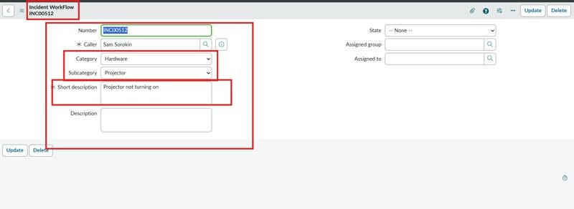
2. | Tune the Model | Hyperparameter Tuning - Not applicable (no ML model). Validation Method - Functional testing with sample tickets; confirmation email checked in System Logs > Emails. | 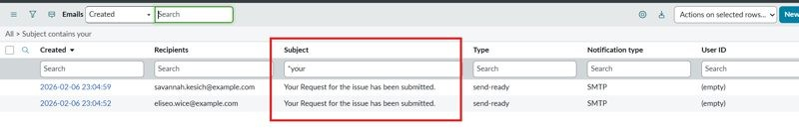

Functional & Performance Testing Template
Model Performance Test

Date | 30 September 2026
Team ID | SWTID-2026-7613
Project Name | Auto Ticket Classification using Flow Designer
Maximum Marks

Test Scenarios & Results

Test Case ID | Scenario (What to test) | Test Steps (How to test) | Expected Result | Actual Result | Pass/Fail
FT-01 | Short Description keyword  - Wi-Fi / Network (e.g., "WiFi not working in library") | Enter Caller and Short Description; save and reload the form | Category = Network, Subcategory = Wi-Fi | Network / Wi-Fi set | Pass
FT-02 | Short Description keyword  - Projector (e.g., "Projector not turning on") | Enter Caller and Short Description; save and reload the form | Category = Hardware, Subcategory = Projector | Hardware / Projector set | Pass
FT-03 | Email notification to the caller | Search the subject in System Logs > Emails and use Preview Mail | Confirmation email is sent to the caller | Email sent | Pass
FT-04 | Category and Subcategory dependency | Open the Incident Workflow form and select a Category | Subcategory choices depend on the selected Category | Choices filtered | Pass
PT-01 | Response Time Test | Use a timer to check content generation time | Should be under 3 seconds | Not tested | N/A
PT-02 | API Speed Test | Send multiple API calls at the same time | API should not slow down | Not tested | N/A
PT-03 | File Upload Load Test (e.g., PDFs) | Upload multiple PDFs and check processing | Should work smoothly without crashing | Not tested | N/A

Project Development Phase Model Performance Test

Date | 30 September 2026
Team ID | SWTID-2026-7065
Project Name | Auto Ticket Classification using Flow Designer
Maximum Marks | 10 Marks

Model Performance Testing:
Project team shall fill the following information in model performance testing template.

S.No. | Parameter | Values | Screenshot
1. | Metrics | Regression Model: Not applicable (rule-based solution, no ML model).  Classification Model: Rule-based keyword classification using Flow Designer (If / Else If on Short Description). Confusion Matrix, Accuracy Score and Classification Report: Not applicable. Verified with 2 test scenarios (Wi-Fi, Projector) - both classified as expected.
2. | Tune the Model | Hyperparameter Tuning - Not applicable (no ML model). Validation Method - Functional testing with sample tickets; confirmation email checked in System Logs > Emails.

Project Development Phase Model Performance Test

Date | 30 September 2026
Team ID | SWTID-2026-7613
Project Name | Auto Ticket Classification using Flow Designer
Maximum Marks

Model Performance Testing:
Project team shall fill the following information in model performance testing template.

S.No. | Parameter | Screenshot / Values
1. | Data Rendered | Ticket records are stored in the custom Incident Workflow table (Number, Caller, Category, Subcategory, Short Description, Description, State, Assigned Group, Assigned to).
2. | Data Preprocessing | No data preprocessing required. The flow reads the Short Description of each new ticket and matches predefined keywords.
3. | Utilization of Data Filters | 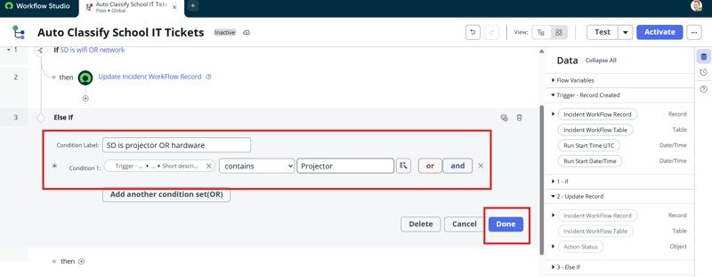  Trigger condition: Category is Empty. If / Else If conditions: Short Description contains WiFi / Network, Projector, Password / Login or Slow / Hanging.
4. | DAX Queries Used | Not applicable - no-code Flow Designer solution; no DAX queries are used.
5. | Dashboard design | No of Visualizations / Graphs - Not applicable (no dashboard in this project)
6 | Report Design | No of Visualizations / Graphs - Not applicable (no report in this project)

Project Development Phase Model Performance Test

Date | 30 September 2026
Team ID | SWTID-2026-7613
Project Name | Auto Ticket Classification using Flow Designer
Maximum Marks

Model Performance Testing:
Project team shall fill the following information in model performance testing template.

S.No. | Parameter | Values | Screenshot
1. | Model Summary | ServiceNow Flow Designer automation (Auto Classify School IT Tickets) to classify school IT tickets using the custom Incident Workflow table with Choice and Reference fields.  Note: When a ticket is created with an empty Category, the flow checks the Short Description for keywords, updates Category and Subcategory, and sends a confirmation email to the caller. | 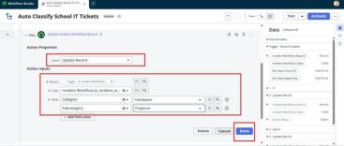
2. | Accuracy | Training Accuracy - Not applicable (rule-based classification, no ML model)  Validation - 2 of 2 test scenarios (Wi-Fi, Projector) classified as expected
3. | Confidence Score (Only Yolo Projects) | Not applicable - not a YOLO project. Classes assigned by the flow (rule-based, no confidence score): Network / Wi-Fi, Hardware  / Projector, Access / Forgot Password, Performance / Slow Computer.

Project Development Phase Performance Test

Date | 30 September 2026
Team ID | SWTID-2026-7613
Project Name | Auto Ticket Classification using Flow Designer
Maximum Marks

Model Performance Testing:
Project team shall fill the following information in model performance testing template.

S.No. | Parameter | Screenshot / Values
1. | Data Rendered | Ticket records are stored in the custom Incident Workflow table (Number, Caller, Category, Subcategory, Short Description, Description, State, Assigned Group, Assigned to).
2. | Data Preprocessing | No data preprocessing required. The flow reads the Short Description of each new ticket and matches predefined keywords.
3. | Utilization of Filters | Trigger condition: Category is Empty. If / Else If conditions: Short Description contains WiFi / Network, Projector, Password / Login or Slow / Hanging.
4. | Calculation fields Used | Not applicable - no calculated fields; Category and Subcategory are set by Update Record actions in Flow Designer.
5. | Dashboard design | No of Visualizations / Graphs - Not applicable (no dashboard in this project)
6 | Story Design | No of Visualizations / Graphs - Not applicable (no story in this project)

User Acceptance Testing (UAT) Template

Date | 30 September 2026
Team ID | SWTID-2026-7613
Project Name | Auto Ticket Classification using Flow Designer
Maximum Marks

Project Overview:
Project Name: Auto Ticket Classification using Flow Designer
Project Description: Auto-classification of school IT tickets using ServiceNow Flow Designer
Project Version: [Version Number] Testing Period: [Start Date] to [End Date] Testing Scope:
Automatic Category / Subcategory classification from Short Description; email notification to caller Classify at creation; dependent Category and Subcategory; automated confirmation email

Testing Environment:
URL/Location: ServiceNow instance - Incident Workflow table and Flow Designer
Credentials (if required): [Username/Password]

Test Cases:

Test Case ID | Test Scenario | Test Steps | Expected Result | Actual Result | Pass/Fail
TC-001 WiFi keyword ("WiFi not working in library") |  | - Enter Caller  - Enter Short Description  - Save and reload the form | Network / Wi-Fi set; email sent to caller | Network / Pass Wi-Fi set;  email sent to caller
TC-002 Projector keyword ("Projector not turning on") |  | - Enter Caller  - Enter Short Description  - Save and reload the form | Hardware / Projector set; email sent to caller | Hardware / Pass  Projector set; email sent to caller

Bug Tracking:

Bug ID | Bug Description | Steps to reproduce | Severity | Status | Additional feedback
BG-001 | [Describe the issue or  bug encountered | [Step 1]  [Step 2]  [Step 3] | [Low/Medi um/High] | [Open/In Progress/ | [Any additional comments or

 | ] |  |  | Closed] | feedback]
... | ... | ... | ... | ... | ...

Sign-off:
Tester Name: [Name of Tester] Date: [Date of Test Completion] Signature: [Tester's Signature] Notes:
- Ensure that all test cases cover both positive and negative scenarios.
- Encourage testers to provide detailed feedback, including any suggestions for improvement.
- Bug tracking should include details such as severity, status, and steps to reproduce.
- Obtain sign-off from both the project manager and product owner before proceeding with deployment.

